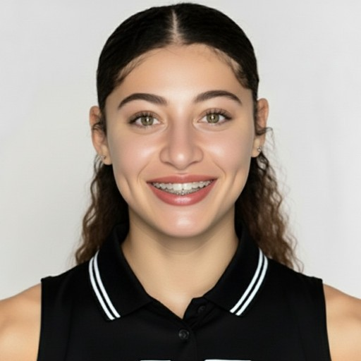Savannah Norfleet

Professional Basketball Player

American

|  |  |  |
| --- | --- | --- |
| **Dynamic 5’10 Guard** with 4+ years of competitive collegiate experience. **Offensive Player of the Year, First All-State, Most Inspirational Player Award**. **State Championship 2nd place finish**.  Evaluated at the **2025 International Combine with a EuroGrade of 2.7**, recognized as one of the top combine talents for mid-level overseas leagues. | | Chicago, United States 1 (773) 895-0365  [Savannahnorfleet@gmail.com](mailto:Savannahnorfleet@gmail.com) |
| **Skills**  Scoring & Offensive Impact *Experienced*  Defense & Versatility *Experienced*  Leadership, Communication, Basketball IQ *Expert*  **Links**  [Mt San Antonio College Highlights](https://youtu.be/OVSOQ4BYkvg?si=r0T0TW2VZTyad0gh)  [Pro Combine Highlights (Eurograde 2025)](https://youtu.be/KVXswOxMpng?si=1qO1LKrVHR_S4J3h) [Pro Combine Full Game #1](https://www.youtube.com/watch?v=pXAJjZhWRF8)  [Pro Combine Full Game #2](https://youtu.be/aQ6s04bX3Ew?si=hojHmYHBY8CzVwWP)  [Pro Combine Championship game](https://youtu.be/wEWGeKSqoAs?si=r6cqD4zaVUpuTetP)  **Languages**  English *Native*  Spanish *Novice*  **Hobbies**  **Running, Modeling, Travel, Community Volunteering**, **Content Creation, Media** | **Employment history**  **Student-Athlete** *Aug 2022 - May 2025*  *Feather River College (California) at Quincy, California*  Led NJCAA scoring with 32.0 PPG NJCAA First Team selection.  **Student-Athlete** *Aug 2022 - Sep 2023*  *Mt. San Antonio College at Walnut, California*  Offensive Player of the Year. First All-State Team  Most Inspirational Player of the Year. 2nd Place State Championship  **Head Coach, Youth Director** *Jan 2023 - Jul 2024 Mac Irvin Fire at Chicago*  Coached the #1-ranked 17U AAU team in the nation.  Managed athlete schedules, enhancing program efficiency and mentorship.  **Personal Trainer & Basketball Coach,** *May 2025 - Present, Chicago*  Train athletes from youth to the NBA, enhancing performance and skills. Develop personalized skill and nutrition plans for diverse athletes.  **Education**  **Kinesiology** *Feb 2001 - Jan 2022*  *Feather River College at California*  Dean’s list  **Associates Kinesiology** *Aug 2023 - Jun 2024*  *Mt San Antonio College at California*  **BA kinesiology** *Sep 2024*  *California State University -Los Angeles*  **References**  **Iva Nikolova**  *Overseas Basketball Scouting Combines Executive*  [scouting@euro-grades.com  1 (305) 204-1389](mailto:scouting@euro-grades.com) | |

Basketball Personnel Scouting Report

**Savannah Norfleet**

Introduction

This assessment examines Savannah Norfleet's basketball abilities. The report provides a detailed analysis of her athletic and technical skills, as well as other relevant qualities. Savannah can play as a large guard, maintain pace, and score from various positions on the court. She demonstrates suitable basketball intelligence for playing alongside skilled teammates.

# Player Profile

Full Name: Savannah Norfleet

Date of Birth:

Height: 5’10

Weight:

Position: PG/Shooting Guard

Current Team:

Handedness: Right hand dominate

Nationality: American/Irish

# Physical Attributes

Savannah Norfleet

* Height and Wingspan: 5’10 with a 6’1 wingspan
* Speed and Agility: She has very good lateral quickness, and she can really get to the basket. She has the quickness and agility to keep her opponents in front of her. She is fairly quick off the floor.
* Strength and Conditioning: She is quick both in the open court. She pushes the ball well from end to end. She finishes well around the rim, and she doesn’t avoid contact.
* Vertical Leap: She averages 4.2 rebounds per game. Knowing that she rebounds the ball well and can push it up the floor with her ability to handle the ball.

# Offensive Skills

She has the intangibles of becoming a treat both in the half and full court. Her court vision and ball-handling skills allow her to play at a high pace. She is a good floor general and can play in a good system.

Finishing:

* Finishes through contact in the post well
* Finish well, going both left and right
* Good in the open court, she can get through defenders
* She finishes well,-- coming off screens and getting downhill
* Very good at the mid-range and good from beyond the arc
* Good at catch and shoot

Ball Handling:

* Handles the ball well in traffic
* Controls it well coming off screens and in the lane
* Pushes it well in transition
* Cross-over dribble is her specialty/Go to move

Passing and Vision:

* Good Basketball IQ
* See the floor well
* Has the capabilities of reading the defense and making precise, timely passes.
* Knows how to read the second defender in the Pick and Roll Defense

# Defensive Skills

She demonstrates strong on-the-ball defense and possesses the physicality required to keep opponents out of the paint. Her ability to read opposing offenses is notable, as she effectively anticipates passing lanes. Additionally, she excels in both offensive and defensive rebounding.

Interior Defense:

* Very good on-ball defense and good anticipation
* Plays physical on the perimeter, which she gets into the passing lanes
* Good help defense in the half-court with decent footwork and communication

Rebounding:

* Good technique and positioning
* The ability to rebound and push it up the floor, she is a treat to transition defense
* Average 4.2 rebounds per game allows for extra possessions for her team

Defensive IQ:

* High IQ: She can predict an opponent’s next move by reading their body language, eyes, and tendencies.
* Situational Awareness: She has a constant awareness of where everyone is on the court-including teammates, opponents, and the ball.
* Positioning and angling: Understanding how to use her body to steer opponents toward dangerous areas on the court.
* Decision-making under pressure: She has the capacity to make quick, smart decisions in high-stress situations.

# Intangibles

* Basketball IQ: She can read the floor, and in special situations. She adapts to evolving tactics.
* Leadership: She inspires her teammates with her playmaking skills.
* Work Ethic: She is a goal setter. Committed to showcasing her talent at the next level. She has resilience after setbacks.

# Statistical Overview

Season Averages: 2022 Season Stats

32.0 ppg/4.2 rpg/2.1 apg/2.2 spg

Led the California Juco league in scoring.

# Strengths

* Transition offense: Putting pressure on teams to get back defensively. They must build a wall against her to keep her out of the paint.
* Ball-handling: The ability to handle the ball in pressure situations, and she is a playmaker. She can create off the dribble even if you run her off the line.
* Shooting: Mid-range game and attacking the rim.

# Areas for Improvement

* Shooting: Be consistent with shooting beyond the arc
* Post: Develop better skills in the post
* Footwork: Lateral quickness

# Projected Potential

She was highly sought after by multiple Division I programs upon graduating from high school. However, circumstances related to coaching prevented her from fully capitalizing on these opportunities. At the junior college level, she demonstrated outstanding performance but encountered another setback. Following an outstanding junior college career, she successfully positioned herself for an opportunity to play at a Division I program; however, her plans were impacted by the onset of the Covid-19 pandemic.

# Recommendations

# Conclusion

Savannah demonstrates the capabilities required for professional play. Her proficiency as a point forward represents a significant advantage for any team. She possesses a comprehensive skill set indicative of strong potential for success at the professional level.